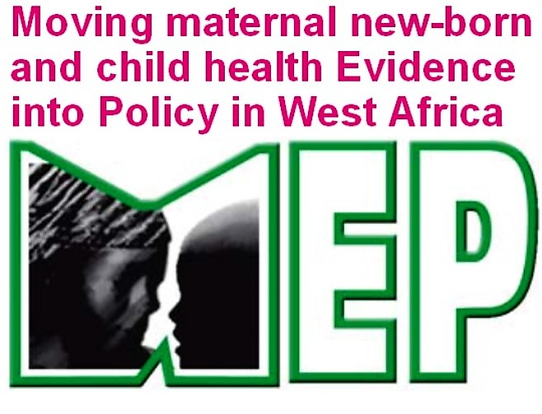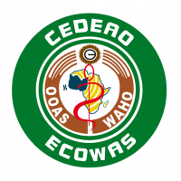

Nigerian Research days for MNCH conference
Concept note
- Context
The organisation of specific days dedicated to research on MNCH in Nigeria; was one the main recommendations from the situation analysis on Knowledge Transfer and evidence use carry out by WAHO as part of Moving maternal newborn and child health Evidence into Policy in West Africa (MEP) in 2015. This request tried to bring all stakeholders together in a platform to foster collaboration between researchers and decision-makers, to share the results of ongoing research and to prepare the use of these results in decision-making and practices.
To ensure ownership of this platform by stakeholders, a feasibility study commissioned by WAHO to gather their views and perspectives on all aspects of the organization of these SMNE research days under the leadership of Nigeria's Federal Ministry of Health. The recommendations of this study served as the basis for the development of this concept note. The keys results of this feasibility study were that participants would include policy makers, implementers, healthcare practitioners, researchers and experts in the area, NGOs, development partners, CSOs including professional associations, community gatekeepers, Federal Ministry of Health and line ministries that are relevant to MNCH and State Ministries of Health. The event will be organise for 3 days with 20 to 50 participants and the mode of delivery would be sessions with peer exchange and oral presentation.. The contents should cover MNCH and adolescent interventions that have worked in Nigeria. Inspiring examples of collaboration that have 'bent the curve', to achieve transformation change in women’s, children’s and adolescents’ health, going far beyond incremental progress, innovations in the six areas of the WHO building blocks, donor support, MNCH research priorities and funding opportunities for the research priorities as well as MNCH and adolescent health in fragile States.
For the first edition, the conference will focus on the IMCHA research projects and some keys other interventions, in order to gradually build the stakeholders and improve the implementation of the conference. Organised by the technical services of Federal Ministry of health (FMOH), the conference will hold from 11 -13 Jullyon Maternal Newborn Child Health 2018 (to be adapted to the official calendar) in Abuja.
- Objectives
The overall objective is to move maternal, newborn and child health evidence into policy in Nigeria, so as to enhance the reduction of maternal and child mortality rates, through the development of more efficient, equitable and sustainable policies, strategies, implementation plans, monitoring and evaluation frameworks and better functioning systems.
The specifics objectives are:
- To present the early findings of the IMCHA projects research and other interventions in MNCH in Nigeria,
- To discuss the use of the research findings/good practices in decision making in MNCH
- To improve the organisation and the sustainability of the Nigeria Research days for MNCH

- Methodology
This is a form of organized sessions with peer exchange and oral presentations to ensure good Knowledge Translation and use of evidence. The organize sessions will be in form of participatory or panel sessions which could be round table discussions, debates, ‘fishbowl’ discussions and group work. This for actively encourage audience participation.
- Expected results
At the end of the conference, the following results are expected:
- The IMCHA research projects ongoing findings and other good practices are shared
- The mechanism of the research findings uses in decision making and practice in MNCH in Nigeria was discussed
- The suggestions for the improvement and the sustainability of the Nigeria Research Day for MNCH conference were proposed
- A final communiqué, on the consensus recommendation around the use of results discussed during the conference, was developed; send to the MOH and Partners.

- Conference agenda
Moderator: Professor Benjamin Uzochukwu; Report: WANEL member
Timing | Activities | Modalities | Expected results | Responsible
DAY 1
8:00 – 9:00 | Registration & networking
9:00 – 9:30 | Session 1: Opening ceremony  -Opening prayer  -Welcome remarks  -Participants presentation  -Agenda amendments | Official remarks on the conference | -Official involvement of FMOH, WAHO DG  -A conference agenda validated | Moderator  WAHO DG  IDRC/Canadian High Commission  FMOH
09:30 – 11:00 | Session 2:  -Status, vision, and research priorities on MNCH in Nigeria (FMOH)  - MEP keys results in Nigeria (Sombie)  - EQSUIT applied for decision making in Nigeria (Pr Uneke ) | Panel discussion after the two presentations. | -Knowledge of politic of MNCH and Research priorities on MNCH  MEP keys results shared  EQUIST evidence-based information shared | Moderator
11:00 – 11:30 | Coffee Break
11:30 – 1:00pm | Session 3: IMCHA projects  -Video Edutainment: Impact on Maternal and Infant Outcomes in Toro, Nigeria: first results.  -Increasing Women's Access to Skilled Pregnancy Care in Nigeria: Results achieved  -Scaling Up Care for Perinatal Depression for Improved Maternal and Infant Health in Nigeria (SPECTRA): Results achieved | Oral presentation of 15 min each and 20 min of discussion  Flyers on the projects will be shared to audience | Actionable results and messages on the research findings and expected using in decision making, MNCH policy or practices shared | PI of Research Projects
1:00 pm – 2:00 pm | Lunch Break
2:00 pm – 3:00 pm | Session 5: Other projects  -Canadian Project Bauchi  - Other research (CEPED) | Oral presentation of 15 min each and 20 min of discussion  Flyers on the projects will be shared to audience | Actionable results and messages on the research findings and expected using in decision making, MNCH policy or practices | Responsible
3:00 pm – 4:00 pm | Session 6: Other projects  - Other research (to be identified)  - Other research (to be identified) | Oral presentation of 15 min each and 20 min of discussion  Flyers on the projects will be shared to audience | Actionable results and messages on the research findings and expected using in decision making, MNCH policy or practices | Responsible
DAY 2
9:00 – 11:00 | Session 7: Capacity Building: Getting results to Policy | -Oral presentation,  -Discussion  -Case study using one the results presented the last day | Knowledge, skills and attitude of participants on getting research results to policy are improved | Moderator  Resource person
11:00 – 11:30 | Coffee Break
11:30 – 1:00 pm | Session 8: Group work  How the results and messages can be used to improve the MNCH in Nigeria (Capitalisation) and keys recommendations | -Presentation of group work ToR  -Fishbowl process for group work | Mechanisms, process of the use of the results to improve MNCH outcomes are well defined and responsible are tasked | Moderator  Group reporters
1 pm – 2:00 pm | Lunch Break
2:00 pm – 4:00 pm | Session 9: Restitution | work Oral presentation of group work findings | Concretes recommendations on the use of results based on the work of each group; that will be used to develop the final communique | Moderator  Reporter
DAY 3
9:00 – 10:00 | Session 10: Validation of the reports and recommendations | -The reporter present notes of report, recommendations and draft of the communiqué  -Amendment by the audience | Reports and recommendations validated | Moderator
10:00- 11:00 | Session 11:Next steps  Modality, content, period and participants of the 2nd edition of the Nigeria research Days for MNCH. | Brainstorming |  | Moderator
11:00 – 11:30 | Coffee Break
11:30 – 12:00 | Session 12: Closing ceremony |  | -Reading of the final communiqué  -Date of the next conference | FMOH
12:00 | Lunch Break
 | END

- Documentation
A documentation process of the conference will be develop to capture the change of perspectives in evidence use among the participants and the lessons learnt imp the implementation. The “Reach, effectiveness, Adoption, implementation and Maintenance” (RE-AIM) evaluation framework will be used for the evaluation and the leaning process throughout the edition of the conference.
The capacity building session aims to increase participants’ knowledge, skills and attitude on “Getting results to Policy”. The Kirpatrick’s four Levels of Training Evaluation will be use to evaluate the capacity building outcomes. The knowledge acquired during the training session can be assess pre/post-test on the concepts covered. The skills and attitude need time to take place and will be measure over the time match with support. The report of the conference will be develop by the reporter in collaboration with the organiser team and the moderator.
- Participants
For this first edition, a specific invitation will sent to participants. Around 80 participants from the FMOH officers, IMCHA research teams, CSOs and research Institutes will founded by WAHO. Below, a non-exhaustive list of participants to invite:
- FMOH: Federal Ministry of Health, Department of Family Health, Department of Planification, Research,

- Partners: UNICEF, UNFPA, WHO, JHPIEGO, USAID, CIDA, Save The Children, JICA, UNWOMEN, Bill & Melinda Gate Foundation, World Bank, Global Affairs Canada,

- NGOs: Evidence4Action, Global Affairs Canada, Malaria Consortium, Society for Family Health (SFH), Marie Stopes International, Well Being Foundation, Nigerian Urban Reproductive Health Initiative (NURHI), Community Health and Research Initiative (CHR), Informed Decisions for Actions in maternal and new-born health (IDEAS), Saving Giving Life (SMGL), Adolescent Health and Information Projects (AHIP).

- Colleges: WACP, Society of Gynaecology and Obstetrics of Nigeria (SOGON), Paediatric Association of Nigeria

- CSOs: Nigerian Health Watch,

- IMCHA research teams: WHARC Benin City, FOMWAN/Bauchi, WHO Collaborative Centre/Ibadan

- Research Institute: CPED, AIHPHSS, Health Policy Research Group, Centre for Population and Reproductive Health, Institute of maternal and child health, Nigeria Institute of Medical Research, Nigeria Implementation Science Alliance (NISA)

- WAHO: Director General, PP/ Research & Health Information, PO/Implementation of MEP project, PO/ Monitoring Evaluation & Learning of MEP project

Glasgow RE, Estabrooks PE. Pragmatic Applications of RE-AIM for Health Care Initiatives in Community and Clinical Settings. Prev Chronic Dis 2018;15:170271. DOI: http://dx.doi.org/10.5888/pcd15.170271
Manabe, Y. C., Zawedde-Muyanja, S., Burnett, S. M., Mugabe, F., Naikoba, S., & Coutinho, A. (2015). Rapid Improvement in Passive Tuberculosis Case Detection and Tuberculosis Treatment Outcomes After Implementation of a Bundled Laboratory Diagnostic and On-Site Training Intervention Targeting Mid-Level Providers. Open Forum Infectious Diseases, 2(1). https://doi.org/10.1093/ofid/ofv030

